**PHINMA University of Pangasinan Online Scheduling Management System**

A Project Study Presented to

the Faculty of the Bachelor Program

College of Information Technology Education

PHINMA University of Pangasinan

In Partial Fulfillment

of the Requirements for the Degree

BACHELOR OF SCIENCE IN INFORMATION TECHNOLOGY

by

De Guzman, Roger Arthur William Alejo

De Vera, Erica Mae Paragas

Elasin, Ralph Wendell Maramba

Enriquez, Oscar Solomon

Maramba, Benjie Bitolinamesa

Villanueva, Glaiza Joyce Mamaril

March 2022

**APPROVAL SHEET**

This project study entitled **PHINMA UNIVERSITY OF PANGASINAN ONLINE SCHEDULING MANAGEMENT SYSTEM** prepared and submitted by **Roger Arthur William Alejo De Guzman, Erica Mae Paragas De Vera, Ralph Wendell Maramba Elasin, Oscar Solomon Enriquez, Benjie Bitolinamesa Maramba, and Glaiza Joyce Mamaril Villanueva** in partial fulfillment of the requirements for the degree BACHELOR OF SCIENCE IN INFORMATION TECHNOLOGY, has been examined and is recommended for acceptance and approval for oral examination.

NAME OF ADVISER, Degree

Adviser

Project Study Committee

PANEL MEMBER (CAPS), Degree PANEL MEMBER (CAPS), Degree

Member Member

NAME OF CHAIRPERSON(CAPS), Degree

Chairperson

PANEL OF EXAMINERS

APPROVED by the Committee on Oral Examination on

__________________ with a grade of _________.

NAME OF CHAIRPERSON(CAPS), Degree

Chairperson

PANEL MEMBER (CAPS), Degree PANEL MEMBER (CAPS), Degree

Member Member

ACCEPTED AND APPROVED in partial fulfillment of the requirements for the degree BACHELOR OF SCIENCE IN INFORMATION TECHNOLOGY.

ARISTOTLE B. LIWANAG, MBA

Dean

College of Information

Technology Education

**PROJECT STUDY ABSTRACT**

1. Title: **PHINMA University of Pangasinan Online Scheduling Management System**-

* 1. Total No of page: ___
  2. Text No of page: ___

2. Author: **[author here, all caps, bold face]**

3. Type of Document: Project Study

4. Keywords: [keywords here]

5. Abstracts:

5.1 **Background of the study**

5.2 **Summary**

5.3 **Findings**

5.4 **Conclusions**

5.5 **Recommendations**

**\* Note: Above should not exceed 3 pages in length**

**ACKNOWLEDGEMENT**

It has not been easy for the Developers to accomplish this capstone project, and they are truly thankful to all who have supported them.

First and foremost, the Developers wish to express their gratitude to **Almighty God** for providing them with the power and motivation to complete this capstone project on a daily basis.

The Developers would like to express their appreciation to **Mr. Aristotle B. Liwanag**, Dean of the PHINMA-University of Pangasinan's College of Information Technology and Education. They appreciate his encouragement and ability to inspire not only the developers, but also all of the students and instructors.

This work would not have been possible without the support of their advisers and instructors.

The Developers are also specially indebted to **Mrs. Angelica F. Vidal** for guiding the Developers to start our capstone project, who have been supportive of their capstone project last semester and who worked actively to provide all their needs to make this capstone project possible with the protected academic time to pursue this.

The Developers appreciate all of the people with whom they've had the pleasure of working on this and other projects. They are grateful for the personal and professional coaching they received, which taught them a lot about capstone projects and life in general. They'd also like to express their gratitude to **Miss Ma. Grace Carpizo**, the capstone project's adviser, served as their educator and mentor, teaching them far more than they could ever give her credit for.

They'd like to express their gratitude to their classmates for their cooperation and support.

Most importantly, their motivation for completing this capstone assignment for their adored parents. They appreciate their love, support, and advice. Thank you so much, and may God bless you!

R.A.W.D.G, E.M.P.D.V, R.W.M.E,

O.S.E,

B.B.M,

G.J.M.V

**DEDICATION**

This capstone project is especially dedicated to the instructors who helped and guided us to successfully complete this project work.

This capstone project is dedicated to our advisers in this school year for their support and taught us how to be confident to finish this project.

This project is dedicated to our parents who have never failed to give us financial and moral support, for giving all our needs during the time we developed our system and for teaching us that even the largest task can be accomplished if it is done one step at a time.

This project is dedicated to all the members of Lock Infinity Group class of 2022 for their sacrifice and cooperation doing this capstone project.

The Developers

**TABLE OF CONTENTS**

Page

TITLE PAGE . . . . . . . . . . . . . . . . . . . . . . 1

APPROVAL SHEET . . . . . . . . . . . . . . . . . . . . 2

PROJECT STUDY ABSTRACT . . . . . . . . . . . . . . . . 3

ACKNOWLEDGEMENT . . . . . . . . . . . . . . . . . . . . 4

DEDICATION. . . . . . . . . . . . . . . . . . . . . . . 7

TABLE OF CONTENTS . . . . . . . . . . . . . . . . . . . 8

LIST OF FIGURES . . . . . . . . . . . . . . . . . . . . 10

CHAPTER

1 PROJECT OVERVIEW

Background of the Study . . . . . . . . . . . 12

Importance of the Study . . . . . . . . . . . 31

Statement of the Problem. . . . . . . . . . . 32

Objectives of the Study . . . . . . . . . . . 33

Definition of Terms . . . . . . . . . . . . . 34

2 METHODOLOGY

Software Development Methodology. . . . . . . 37

Scope and Delimitation. . . . . . . . . . . . 42

Data Gathering Techniques . . . . . . . . . . 43

Sources of Data . . . . . . . . . . . . . . . 45

3 DISCUSSION OF FINDINGS

Answer for SOP #1 . . . . . . . . . . . . . . 59

Answer for SOP #2 . . . . . . . . . . . . . . 60

Answer for SOP #3 . . . . . . . . . . . . . . 60

System Design . . . . . . . . . . . . . . . . 61

Physical Design . . . . . . . . . . . . . . . 64

4 CONCLUSIONS AND RECOMMENDATIONS

Conclusions . . . . . . . . . . . . . . . . . 65

Recommendations . . . . . . . . . . . . . . . 65

REFERENCES. . . . . . . . . . . . . . . . . . . . . . . 67

APPENDICES

A Letter for Panelist . . . . . . . . . . . . . 72

B Informed Consent and Survey Questionnaire . . 73

C SUS Survey . . . . . . . . . . . . . . . . . 77

D Prototype . . . . . . . . . . . . . . . . . . 80

CURRICULUM VITAE . . . . . . . . . . . . . . . . . . . 84

**LIST OF FIGURES**

Figure No. Title Page

1 FDD 5 Stages Processes . . . . . . . . . . . 39

2 Simple Random Sampling . . . . . . . . . . . 46

3 Location Map . . . . . . . . . . . . . . . . 48

4 Respondents Profile . . . . . . . . . . . . . 49

Figure 4.1 . . . . . . . . . . . . . . . . . 50

Figure 4.2 . . . . . . . . . . . . . . . . . 51

Figure 4.3 . . . . . . . . . . . . . . . . . 52

Figure 4.4 . . . . . . . . . . . . . . . . . 53

Figure 4.5 . . . . . . . . . . . . . . . . . 54

Figure 4.6 . . . . . . . . . . . . . . . . . 55

Figure 4.7 . . . . . . . . . . . . . . . . . 56

Figure 4.8 . . . . . . . . . . . . . . . . . 57

Figure 4.9 . . . . . . . . . . . . . . . . . 58

Figure 4.10 . . . . . . . . . . . . . . . . 59

5 Conceptual Design . . . . . . . . . . . . . . 62

6 Logical Design . . . . . . . . . . . . . . . 63

7 Physical Design . . . . . . . . . . . . . . . 6

Chapter 1

**Project Overview**

# Background of the Study

Technology has also given us brand new devices in recent decades, like smartwatches, tablets, and voice assistant devices. With these devices, we can do things like transfer money instantly and make purchases for everything from clothes, food delivery, groceries, furniture, and more. Technology has changed how we entertain ourselves, meet each other, and consume all types of media. It’s made fun advancements, but it’s also made important advancements in safety when it comes to home security and medical devices.

Technology brought a massive change in our society today. It affects public transportation, businesses, communication, etc. “Technology is the making, modification, usage and knowledge of tools, machines, techniques, crafts, systems and methods of organization, in order to solve a problem, improve a pre-existing solution to a problem, achieve a goal, handle an applied input or output relation or perform a specific function. It can also refer to the collection of such tools including machinery, modifications, arrangements and procedures.” One of the remarkable and much known products of technology advancement is the conversion of manually-operated systems into automated systems. Automation produces a great impact in the lives of man, particularly in the field of industry, business, medicine and education.

Digital technology has changed what people term as “media.” The influence of new technology on media is apparent since a media company isn’t necessarily a news platform anymore. A media company is now any company that helps pass information across the globe, including social media platforms like Facebook and Twitter. Social media isn’t the only big statement digital technology has made. Neither is social media the only way technology has had an impact in everyone’s life.

There is no denying that the future of technology will continue to revolutionize our lives. In a few years, driverless cars may be the norm for everyone, and robots will be commonplace in factories. Future technology is sure to transform our lives in unbelievable ways, but here we

highlight the many common ways technology is changing our lives today.

Appointment scheduling solutions have become a staple among different business types and individuals. They make it easy for businesses to offer their services and set up meetings. They benefit large and small companies—SMBs are heavily dependent on these tools.  Clearly, they work for businesses and individuals.

* 50% of bookings that happen during working hours are made on the go. (Phorest, 2019)
* 80% of clients use mobile devices to book appointments while 16% and 2% are made from desktops and tablets, respectively. (BookedIn, 2019)
* 74% of clients cancel bookings through email while 26% do it via SMS. (BookedIn, 2019)
* 68% of patients say they’re more likely to choose practices that offer the option to book, change, or cancel appointments online. (patientpop.com, 2020)
* 63% of telehealth encounters involved female patients. (US Center for Disease Control, 2020)
* 18-49 years – The median age of most telehealth encounters. (US Center for Disease Control, 2020)
* 60% – the percentage of online booking rates that spas and salons can achieve. (Zenoti)
* Spa and salon customers who book online make frequent visits. (Zenoti)
* 38% of spa and salon bookings go for same-day appointments. (Zenoti)
* 79% of appointments booked by men are for cycling and triathlon coaching appointments. (Zenoti)
* 88% of appointments booked by women are with beauty salons and spas. (Zenoti)

Researchers and developers will benefit from this project because it will provide them an idea of how to start similar projects. It will also serve as a guide to the types of projects they intend to propose in the future. This is really beneficial to students and parents, particularly now that we are dealing with a pandemic.

The developers will create a mobile-based application in which students who have enrolled for this semester can directly select their slots, purpose of transaction and the day they decided to schedule to pay tuition fees and enrollment fees. They'll use their Phinma Gmail account to sign in. This is the problem; whenever we have transactions to complete on campus, we see a big line. This system will allow you to request a specific transaction schedule using the mobile application.

This project is a mobile-scheduling application for University of Pangasinan students, allowing them to schedule their transactions and avoid long lines. This application's user-friendly design will make it simple for users to select the scheduling choices that they desire. The PHINMA - University of Pangasinan's schedule was created with the availability of personnel and students in mind.

**Company Profile**

  In 1925, The University of Pangasinan started operation in 1925 as the Dagupan Institute, which offered elementary, secondary and vocational courses. It was founded by Dean Francisco Benitez of the University of the Philippines, who became the chairman of the Board of Directors; Dr. Blas F. Rayos; Dr. Apolinario delos Santos, then President of the University of Manila; Dr. Mariano delos Santos, then Dean of the University of Manila; Dr. Sylvestre Pascual; and Dr. Blas F. Rayos, then Dean of the College of Education of the University of Manila. Rayos became the president of the school and headed it for 45 years until 1975 when he died and was succeeded by his son, George O. Rayos, who served as president until 1987.

  In 1937, the College of Liberal Arts was established with the president Blas F. Rayos Sr. as its first dean.

  In 1941, the school was renamed the Dagupan Junior College. Its operation was interrupted by the outbreak of World War II in December 1941. It resumed operation in 1945 immediately after the war. Four courses were added to its offering soon after. These were Civil Engineering, Architecture, Graduate School, and Secretarial Science. Shortly thereafter, additional courses were offered such as Secondary Education, Law, Home Economics, Nursing, and Commerce, with majors in Accounting, Management, Banking and Finance, and Economics.

  In 1950, the school assumed the name Dagupan Colleges, and the Graduate School added courses leading to the degrees of Master of Arts in Philosophy and Master of Science in Business Administration. The school started a review class in Nursing in 1954. Eventually, review classes in Accounting, Civil Engineering and Law were offered. The year 1959 saw further expansion of curricular offerings with the opening of courses leading to the degrees of Bachelor of Science in Foods and Nutrition, and Bachelor of Science in Journalism.

In the next decade following were added: the organization of Naval Reserve Officers' Training Corps (NROTC) and the Naval Women's Auxiliary Corps in 1960, and the offering of the Sanitary Engineering course in 1965.

  On July 3, 1968, the college was converted into a university by virtue of the University Charter granted by the Department of Education. There forth, the school operated as the University of Pangasinan.

  In 2009, it became a member of the PHINMA Education Network.

**Review of Literature**

**According to Alarith Uhde, Matthias Laschke, Marc Hassenzahl (22 April 2021)** Shift scheduling impacts healthcare workers' well-being because it sets the frame for their social life and recreational activities. Since it is complex and time-consuming, it has become a target for automation. However, existing systems mostly focus on improving efficiency. The workers' needs and their active participation do not play a pronounced role. Contrasting this trend, we designed a social practice-based, worker-centered, and well-being-oriented self-scheduling system which gives healthcare workers more control during shift planning. In a following nine-month appropriation study, we found that workers who were cautious about their social standing in the group or who had a more spontaneous personal lifestyle used our system less often than others. Moreover, we revealed several conflict prevention practices and suggested shifting the focus away from a competitive shift distribution paradigm towards supporting these pro-social practices. We conclude with guidelines to support individual planning practices, self-leadership, and for dealing with conflicts.

**According to Sarah Clinch, Mateusz Mikusz, Ivan Elhart, Nigel Davies, Marc Langheinrich (11 December 2019)**, Digital displays are a ubiquitous feature of public spaces; London recently deployed a whole network of new displays in its Underground stations, and the screens on One Time Square (New York) allow for presentation of over 16,000 square feet of digital media. However, despite decades of research into pervasive displays, the problem of scheduling content is under-served and there is little forward momentum in addressing the challenges brought with large-scale and open display networks. This paper presents the first comprehensive architectural model for scheduling in current and anticipated pervasive display systems. In contrast to prior work, our three-stage model separates out the process of high-level goal setting from content filtering and selection. Our architecture is motivated by an extensive review of the literature and a detailed consideration of requirements. The architecture is realized with an implementation designed to serve the world's largest and longest-running research testbed of pervasive displays. A mixed-methods evaluation confirms the viability of the architecture from three angles: demonstrating capability to meet the articulated requirements, performance that comfortably fits within the demands of typical display deployments, and evidence of its ability to serve as the day-to-day scheduling platform for the previously described research testbed. Based on our evaluation and a reflection on paper as a whole, we identify ten implications that will shape future research and development in pervasive display scheduling.

**According to Venkata P. Modekurthy, Abusayeed Saifullah, & Sanjay Madria (29 July 2021)**, The concept of Industry 4.0 introduces the unification of industrial Internet-of-Things (IoT), cyber physical systems, and data-driven business modeling to improve production efficiency of the factories. To ensure high production efficiency, Industry 4.0 requires industrial IoT to be adaptable, scalable, real-time, and reliable. Recent successful industrial wireless standards such as WirelessHART appeared as a feasible approach for such industrial IoT. For reliable and real-time communication in highly unreliable environments, they adopt a high degree of redundancy. While a high degree of redundancy is crucial to real-time control, it causes a huge waste of energy, bandwidth, and time under a centralized approach and is therefore less suitable for scalability and handling network dynamics. To address these challenges, we propose DistributedHART—a distributed real-time scheduling system for WirelessHART networks.

The essence of our approach is to adopt local (node-level) scheduling through a time window allocation among the nodes that allows each node to schedule its transmissions using a real-time scheduling policy locally and online. DistributedHART obviates the need of creating and disseminating a central global schedule in our approach, thereby significantly reducing resource usage and enhancing the scalability. To our knowledge, it is the first distributed real-time multi-channel scheduler for WirelessHART. We have implemented DistributedHART and experimented on a 130-node testbed. Our testbed experiments as well as simulations show at least 85% less energy consumption in DistributedHART compared to existing centralized approaches while ensuring similar scheduling.

**According to Djellel Difallah, Alessandro Checco, Gianluca Demartini, Philippe Cudré-Mauroux (21 February 2019)**, Crowdsourcing has become an integral part of many systems and services that deliver high-quality results for complex tasks such as data linkage, schema matching, and content annotation. A standard function of such crowd-powered systems is to publish a batch of tasks on a crowdsourcing platform automatically and to collect the results once the workers complete them. Currently, these systems provide limited guarantees over the execution time, which is problematic for many applications. Timely completion may even be impossible to guarantee due to factors specific to the crowdsourcing platform, such as the availability of workers and concurrent tasks. In our previous work, we presented the architecture of a crowd-powered system that reshapes the interaction mechanism with the crowd. Specifically, we studied a push-crowdsourcing model whereby the workers receive tasks instead of selecting them from a portal.

 Based on this interaction model, we employed scheduling techniques similar to those found in distributed computing infrastructures to automate the task assignment process. In this work, we first devise a generic scheduling strategy that supports both fairness and deadline-awareness. Second, to complement the proof-of-concept experiments previously performed with the crowd, we present an extensive set of simulations meant to analyze the properties of the proposed scheduling algorithms in an environment with thousands of workers and tasks. Our experimental results show that, by accounting for human factors, micro-task scheduling can achieve fairness for best-effort batches and boosts production batches.

**According to Sunan Parera, Hushni Teja Sukmana, Luh Kesuma Wardhani (April 2016)**, The objective of this research is about building a class scheduling application using genetic algorithms. The parameters used in genetic algorithms namely: iteration, PM (Probability Mutation), PC (Probability crossover). In the Faculty of Science and Technology at UIN Jakarta, class schedules are built by a staff. The staff faces a number of obstacles when building the schedule, among others: the limitations of the classroom and schedule of lectures, and the large number of students. However, it is able to overcome the obstacles but it takes quite a long time to build. To optimize the tasks, an application using genetic algorithms is suggested. In this research, interviews and literature studies are used as research methodology, Waterfall as application development methods and genetic algorithms for scheduling. This application was developed using HTML, PHP, and MySQL. To get the optimal parameter values, some variance of iteration (ns), PC, PM values were tested. The results show that the optimal values for gaining the best schedule are a maximum of 20 iterations, PC 0.8 and PM 0.01. Using these values, the class scheduling application generates approximately 1,201 without any clash among the data and this application can facilitate the building of class schedules.

**Scheduling and lot sizing with sequence-dependent setup**

Abstract

This paper reviews the literature related to the class of scheduling problems that involve sequence-dependent setup times (costs), an important consideration in many practical applications. It focuses on papers published within the last decade, addressing a variety of machine configurations including single machine, parallel machine, flow shop, and job shop systems and reviews the optimization and heuristic solution methods used for each category. Since lot sizing is so intimately related to scheduling, this paper reviews work that integrates these issues in relationship to each configuration. This paper provides a perspective of this line of research, gives conclusions, and discusses fertile research opportunities posed by this class of scheduling problems.

**Outpatient Scheduling in Health Care:**

Abstract

This paper provides a comprehensive survey of research on appointment scheduling in outpatient services. Effective scheduling systems have the goal of matching demand with capacity so that resources are better utilized and patient waiting times are minimized. Our goal is to present general problem formulation and modeling considerations, and to provide taxonomy of methodologies used in previous literature. Current literature fails to develop generally applicable guidelines to design appointment systems, as most studies have suggested highly situation-specific solutions. We identify future research directions that provide opportunities to expand existing knowledge and close the gap between theory and practice.

**Class Scheduling System for Selected State University**

Abstract

Expensive academic resources such as the laboratory rooms as well as the expertise of some faculty members are usually being shared too. However, problems regarding sharing. One of which stems from the conflict in class schedules prepared by the school administrators every semester. Currently, most of those parent universities are manually collating the class schedules from their different satellite campuses. It’s very important that class schedules be accurate and reliable for so many obvious reasons. Thus, this study aimed to develop a new system that will provide those colleges and universities with satellite campuses a new, easy and quick way of creating and generating room, class and individual faculty time-tables and at the same time allows users to automatically detect and prevent conflicts upon the creation of schedules. The study used an appropriate development method for the system design and analysis. Then, the researchers chose the most suitable programming language and database that were utilized in the development of a reliable scheduling system intended for deployment via a suitable on-line access. The output was evaluated based on the ISO 9126 Software Quality Assurance Model

**Rationale**

Owning and running your own business is a huge undertaking. It can feel like there are a thousand things to do all at once on a daily basis. Scheduling systems are designed to help you keep on top of everything you need to get done. Online task management software quickly shows you what is on your list for each day and what is coming up in the near future. In addition, you can reassign projects to different days or even different staff members. This allows you to use more of your time getting stuff done and less just making lists and planning.

One of the benefits of using a scheduling system in your business is that you can set up tasks in order of priority. This allows you to focus on those tasks that are more important or have rigid deadlines first. Without using a software system, you must keep track of deadlines and priorities on your own. That’s not always easy when you’re extremely busy and sometimes things get missed.

It can also make you feel like you’re buried beneath a mountain of work with not enough time to get it all done. As a result, your work quality could suffer which could draw customer complaints and loss of revenue. You probably have a lot on your plate as a business owner and at times your schedule may change when you’re not at work. Using a scheduling system in your business can help with that issue. One of the really cool features of most task management software systems is the ability to schedule and track projects on the go. Apps are available to install on your smartphone so you can make changes in real time as you need to. In addition, as your staff completes work assignments alerts can be sent straight to your phone to let you know. That’s a more efficient way to keep track of workflow in your business than to call constantly and check in with employees.

Another of the benefits of using a scheduling system in your business is that it strengthens teamwork. For example, you can assign a task to more than one person with instructions that they collaborate to complete it. This type of task management allows employees to work together, communicate thoughts and ideas, and motivate each other. When team members draw closer together in their work it improves morale. It can even positively affect efficiency and productivity as well as the entire business environment. It’s certainly true that there are lots of things to do when you are a business owner. Rather than becoming overwhelmed, let the benefits of using a scheduling system in your business pave the path to success.

**Situational Analysis of the Research Topic**

This research study's output is the development of a mobile application that can help students manage their time effectively by falling in line. Essentially, we will create an application that will allow students to schedule their transactions and will provide them with a queue number by the specified day. We will also provide a monitor interface so that students can see which queue number is being processed at any given time. This will allow students to better manage their time while also preventing the spread of COVID-19 due to overcrowding in the school gym.

We are now at the methodology stage, having gathered plans for creating this application and validating our research. We created a methodology plan using the Feature Driven Development method to help us guide our path throughout the development of this application. We needed to ensure the feasibility of this project as well as its effectiveness to our fellow PHINMA University of Pangasinan students.

For the design analysis, we wanted to ensure that our mobile application would appear modern. We intended to create this application with a UI-Friendly and modern-friendly design to make identifying the function of this application much easier and more comfortable for users.

This research also has strengths, weaknesses, opportunities, and threats. We ensure that we want to make this project open to all capabilities and also its weaknesses. Our application has a distinct design, a trendy customization and also an easy function because of its UI friendly design. The promised functions are also granted for the users and it will be easy for them to use this application. However, our application’s purpose is only valuable because of our specified problems; the chance of COVID spreading. While we thought about our purpose of making this application, it was indeed because of our desire in preventing the spread of COVID. But we have seen this as an opportunity even when the COVID-19 is already gone. Students can continue to use this application as a necessity because we have been experiencing the same issue (long queue lines) since before COVID-19 spread.

# Importance of the Study

The findings of this study would be of great help to those who are concerned with the amount of people crowding in one place just to have their errands done.

This shall provide significant benefits to the following entities:

To the University. This will assist the institution in continuing its commitment to responding to community needs and offering high-quality service. This will allow for improved handling of day-to-day transactions on campus.

To the Students. This will be more efficient for them because they will not have to waste time waiting in huge lines to pay tuition fees, enrollment and other transactions to different departments.

To the Employees. The proposed system will allow employees to inquire about their work on a timely basis, allowing them to accomplish their jobs effectively while also avoiding having to deal with a long line of transactions on campus.

To the Developers***.*** The developer's application development skills will be enhanced as a result of the knowledge and experience gained during the study's development.

To the Future Developers. This project will inspire future developers to undertake similar studies on a larger scale, and it will also provide useful information that will enable them in improving or developing a system that is similar to the one described.

# Statement of the Problems

This project aims to design and develop an Online Scheduling Management for PHINMA UNIVERSITY OF PANGASINAN

Specifically, it shall seek to answer the following questions:

1. What are the issues in the existing Scheduling System of PHINMA University of Pangasinan?

2. What are the features of the proposed Online Scheduling System for PHINMA University of Pangasinan?

3. What is the level of acceptability of the proposed Online Scheduling System for PHINMA University of Pangasinan?

# Objectives of the Study

The study aims to design and develop an Online Scheduling System for PHINMA University of Pangasinan that is intended to provide a more precise method of scheduling any transactions that occur on campus.

Specifically, it aims to achieve the following:

1. To identify the issues in the existing Scheduling System of PHINMA University of Pangasinan;

2. To enumerate the features of the proposed Scheduling System of PHINMA University of Pangasinan; and

3. To determine the acceptability level of the proposed Scheduling System of PHINMA University of Pangasinan.

# Definition of Terms

The following terms are conceptually and operationally defined in order to provide a clear definition of the primary notion used in this study.

Application. A program used by the developers to complete the project.

Design. A system description that defines numerous components and how they interact with one another, as well as a more specific description of each of those components that allows them to be produced

Developers. A group of students will work together to build a scheduling app.

Digital Technology. These are data-generating, data-storage, and data-processing electronic equipment, systems, devices, and resources.

Employees. Inside the campus of PHINMA - University of Pangasinan, a group of personnel performs their jobs.

Features. A software system's functional unit that satisfies a need, represents a design decision, and displays essential information that must be followed.

Future Developers. A BSIT student who will go on to be developers in the future.

Online. Allows us to do an electronic transaction to make our tasks easier.

Pandemic. A pandemic illness outbreak that affects a whole country or the entire world.

Proposed. A probable project strategy for the group.

Scheduling. An appointment with a specific time that must be attended to on that specific day and time.

Technology. The application of scientific knowledge to real human life goals, as well as the project's objective of implementing an application.

Transactions. A variety of day-to-day queries with different purposes on campus.

University. An institution where students study and take modules, as well as purchase uniforms and pay school fees.

Mobile-Based Application. The aim of the developers is to develop a type of application software designed to run on a mobile device, such as a smartphone or tablet computer.

**Chapter 2**

**METHODOLOGY**

This chapter presents software development methodology that was used in this study. The data gathering techniques, and other sources of data are also presented in this chapter.

# Software Development Methodology

# A system development methodology refers to the framework that is used to structure, plan, and control the process of developing an information system. Over the years, a *wide* range of such frameworks have emerged, each with its own set of recognized strengths and weaknesses.

  Choosing the appropriate methodology for the system would contribute to the reduction of possible risks and for the most efficient way of completing the project. Each of the available methodologies is best suited to specific kinds of projects, based on various technical, organizational, project and team considerations.

A developer has used an agile software development methodology to design a computer operating system. Featured Driven Development (FDD) is thought to be the best method for developing a systematic plan for the development of a software system. FDD claims to have a track record of repeatable success in software projects.

  Feature Driven Development (FDD) is a methodology that aims to give developers the largest amount of time possible to work on a software project. It has more formal requirements and steps than other software methodology, but adds a precise tracking of progress. Feature Driven Development (FDD) involves showing that a developer can start a project with a clear understanding of the domain in which he or she is working, and then use that understanding to formulate a rough plan without getting stuck in analysis and design paralysis. FDD methodology processes involve giving the developer the largest amount of time to complete the project in building the features individually.

The processes that make up FDD are structured around defining every element of a project as a feature, then designing and building each feature in an iterative manner.

Featured Driven Development

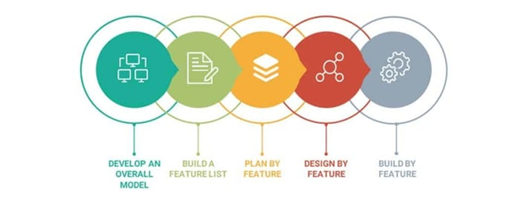

Figure 1: FDD 5 Stages Processes

Develop an Overall Model. The developers create a development plan in order to create an overall model of the domain. This is done to define the system's scope and to provide a shared understanding of the domain.

In this phase, the developers discussed how the proposed system works from the process flow during this phase. The proposed system's layout was visualized and built by the developer. Because this phase is more concerned with layout than content, the developers concentrated on creating the architecture and organization of the prototype's parts. The developer was able to determine the system's scope in this manner.

Build a Feature List. The developers compile a comprehensive list of features and organize them into feature sets, then major feature sets.

During this phase, the developers listed all of the features that are required based on the requirements gathered to make the proposed system complete and fully functional. Some minor features are grouped together under a major feature with which it interacts and is labeled as one group. As a result, the features list became more organized.

Plan by Feature. The developers create a development plan that specifies the request in which feature sets will be realized.

During this phase, the developers worked on each of the features separately. The developer explained how the features function and how they are integrated into the system.

Design by Feature. The developers create feature teams and designs through a series of design by feature and build by feature iterations.

  In this phase, the developers were concerned about the layout and functionality of the feature groups. To avoid a chaotic layout of the proposed system's aftermath, the developers ensured that each feature design was complemented by the other. During this phase, some designs were disregarded or changed because they were deemed inappropriate, and the functions of each feature were discussed.

  Build by Feature. The developers construct each feature set one at a time until it is completed. This is the most essential part of the FDD methodology, and it receives the most time for completing the proposed system.

  During this phase, the developers coded the proposed system and developed features. The coding of the feature's functionalities was presented, completing the working proposed system with all of the features' designs and functionalities. Following the coding, the proposed system was tested to ensure that each feature and component functioned as intended.

**Scope and Delimitation**

For PHINMA-University of Pangasinan, the developers are working on an Online Scheduling Management. In the CITE Department, this comprises tuition and enrollment. The system will have the following features: One account automatically registered per student number, real-time updates if the slots are full per day, and real-time monitoring for the current serving queue number. Each teller also has their own unique interface for validation. The user will log in using their PHINMA gmail account. After the user has decided and entered his or her selected department, transaction, and date, the user will click proceed to display the overview screen. After accessing the application, the user needs to screenshot the overview of his or her transaction for proof of transaction and also to save his or her queue number for that chosen day.

This mobile application will only cover the transaction schedules of students. This project is no longer focused on receiving payment or responding to questions regarding your transactions on campus. This application will only be used on campus to schedule transactions. The findings of this study were based on the answers of the respondents in the instrument used. The interpretation of the results is limited only to the statistical tools in the study.

# Data Gathering Techniques

To determine the study's worth and significance, the developers used the instruments and techniques Methodology expected to complete the development of an PHINMA-Online Scheduling Management System, which included observation, personal interviews with target respondents, document analysis, and the creation of evaluation forms.

The data was collected at a time that was convenient for the respondents and the developer to interact, resulting in a higher level of knowledge acquisition that was critical to meeting the study's objectives.

Observation. This is a direct method of obtaining information about how the current system operates. The developer observed the flow of the transaction processes and studied how respondents who are familiar with the current system react in terms of evaluating the system with which they are familiar.

Interview. The developer conducted a series of interviews with the staff in order to better understand the system's processes and identify the issues that needed to be addressed. An interview was conducted in order to effectively gather all of the necessary information.

Document Analysis. The developer gathered data and information from a literature review, which supported the developer in adapting the same document for use in the proposed online scheduling management.

Survey. The developer gathers information from (a sample of) individuals to obtain data about a service, or process. Survey gathers information from a targeted group of people about their opinions, behavior, or knowledge.

Construction of the Evaluation Form. The developer created an evaluation form that was used to evaluate the proposed system. Respondents were asked to rate the existing and proposed systems using the criteria provided.

# Sources of Data

In this project, data can be defined as quantitative values of a variable. It can be numbers, figures, images or words. Students at the PHINMA-University of Pangasinan will be the sources of our data to gather data for the proposed project entitled **PHINMA University of Pangasinan Online Scheduling Management System**. It is a very important part of a capstone project work because it enables the developers to make decisions related to the information available and also to understand how helpful is the information that will assist in carrying forward the research work. The type of data collection we'll be gathering is primary data via an online survey questionnaire.

Primary Data

It is usually collected from the source where the data originally originates from and is regarded as the best kind of data in research. CITE students at PHINMA-University of Pangasinan will answer an online survey questionnaire created with Google Forms to collect data. The advantages of Primary Data are data interpretation is better and targeted issues are addressed.

Sampling Techniques

Probability sampling technique was applied in this project since every member of the population has a probability of being chosen. It is primarily utilized in quantitative studies. We will use Simple random sampling in Probability Sampling methods because in a simple random sample, every member of the population has an equal probability of being selected.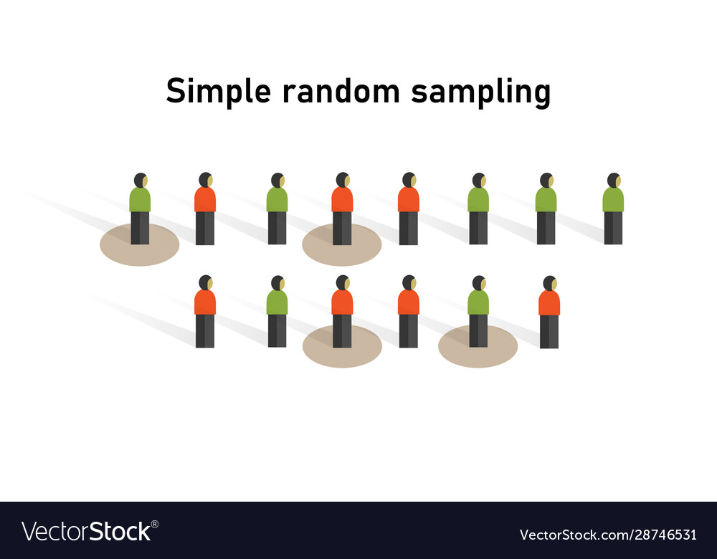

Figure 2: Simple Random Sampling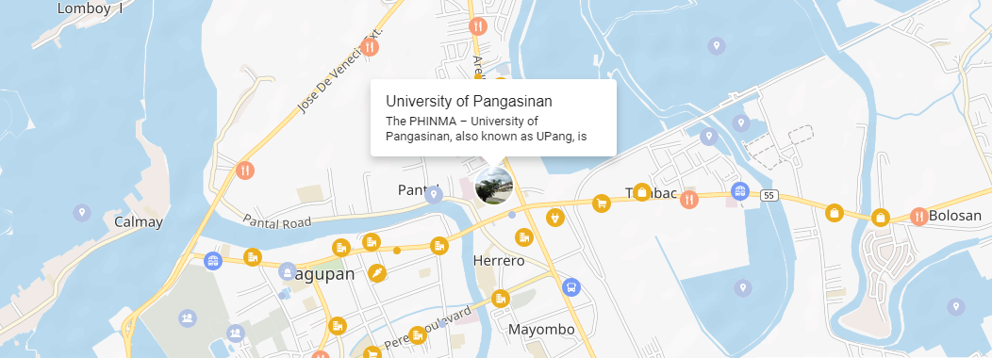

The developers used the 100 respondents of CITE Department in all year levels of PHINMA-University of Pangasinan. The CITE Department were chosen for their insight about our project entitled “PHINMA-University of Pangasinan Online Scheduling Management System”

The developers will be conducting the project at the PHINMA-University of Pangasinan of Dagupan City. It is located in Arellano Street, Downtown District, Dagupan City, Pangasinan. The story of the PHINMA University of Pangasinan started in 1925. Francisco Benitez, Dr. Apolinario de los Santos, Dr. Sylvestre Pascual and Dr. Blas F. Rayos, all esteemed Pangasinenses, built the Dagupan Institute, a school which offered primary, secondary, and vocational education. The Institute was renamed to Dagupan Junior College after the Second World War, expanded its course offerings and added a Graduate School. In 1950, the school was transformed and became Dagupan Colleges.



Figure 3: Location Map

Chapter 3

**DISCUSSION OF FINDINGS**

This chapter presents the developers' findings, analysis, and interpretations of data acquired with the main objective of studying current transaction processing at the PHINMA-University of Pangasinan.

Before performing the survey, we chose the CITE Department as our respondents, and it assessed the profile of those who successfully completed the survey. In this figure, it has been shown that (4) first-year students, (7) second-year students, (89) third-year students, and no fourth-year students responded to the questionnaire.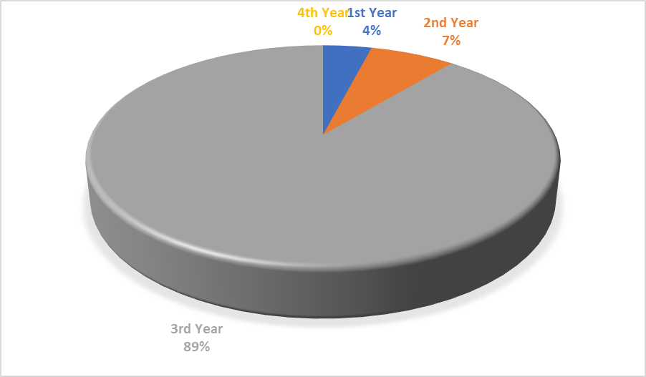

Figure 4: Respondents Profile

Figure 4.1 This figure represents how respondents feel about the current transaction efficiency procedure in the gym when paying tuition fees or enrolling in classes. Students may line up for a lengthy period to pay school fees, as seen in the figure. 17 Always, 32 Often, 48 Sometimes, 2 Rarely, and 1 Never were the answers given by the respondents.

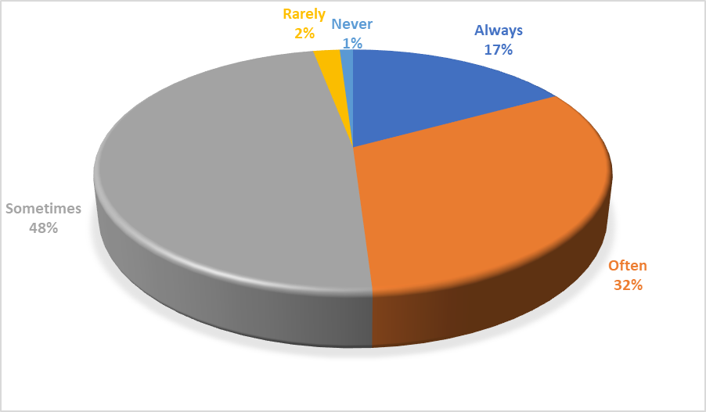

Figure 4.1

This figure represents how respondents deal with issues related to transaction processing. It shows that respondents sometimes have difficulties when processing a transaction. They answered 7 times for Always, 24 times for Often, 49 times for Sometimes, 17 times for Rarely, and 3 times for Never.

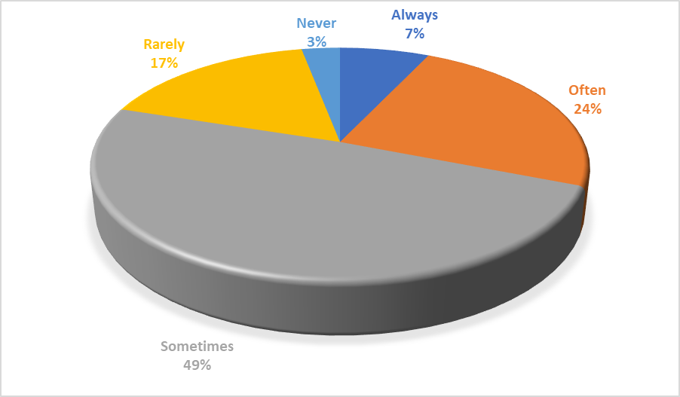

Figure 4.2

This figure represents how respondents perceive the present transaction process to be beneficial during COVID. Respondents found it useful in the COVID Pandemic on sometimes, and they also responded 22 in Always, 35 in Often, 37 in Sometimes, 6 in Rarely, and 0 in Never.

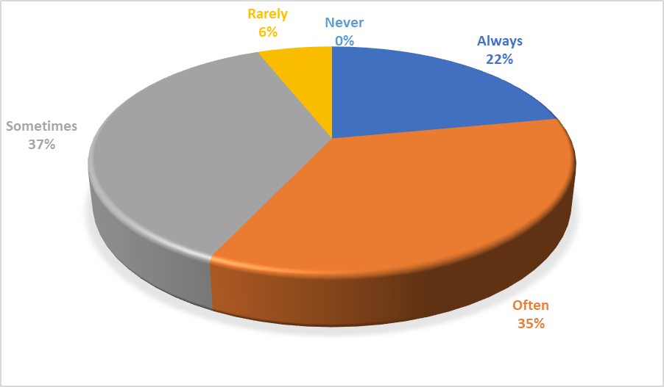

Figure 4.3

This figure indicates how respondents would prefer a mobile application that can efficiently handle transactions based on the day slot you've selected (Real time queueing system). Almost half of the respondents said they'd prefer a mobile app, with the remaining 26 saying it's likely, 26 saying it's neutral, 1 saying it's not likely, and no one saying it's very unlikely.

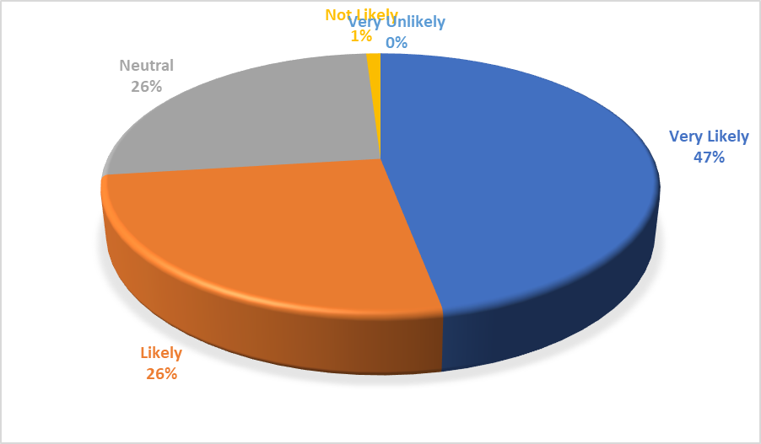

Figure 4.4

This figure indicates how respondents want to make their transactions more convenient without having to queue at school. Other respondents answered 20 in Likely, 19 in Neutral, 3 in Not Likely, and 1 in Very Unlikely, and 57 out of 100 respondents were willing to make their transactions more convenient than waiting so long.

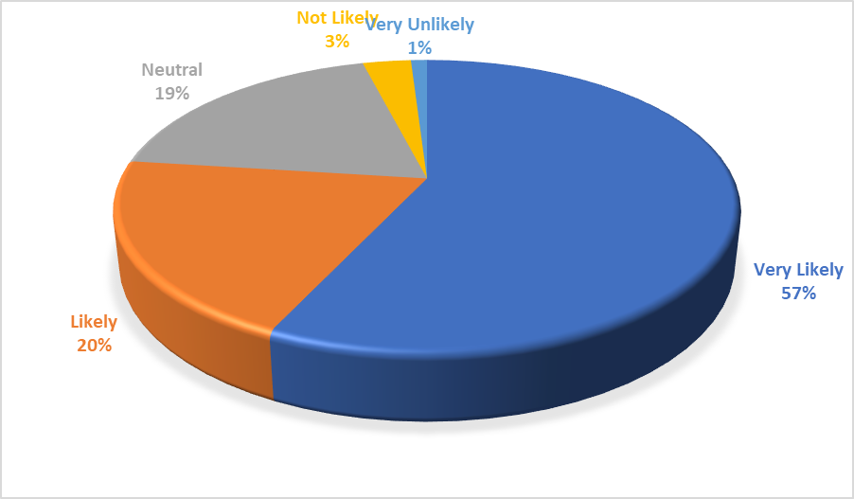

Figure 4.5

This figure indicates how quickly respondents can pay their tuition or complete other transactions at the University of Pangasinan. These are the results: 10 Very Satisfied, 32 Satisfied, 49 Neutral, 8 Less Satisfied, and 1 Very Unsatisfied.

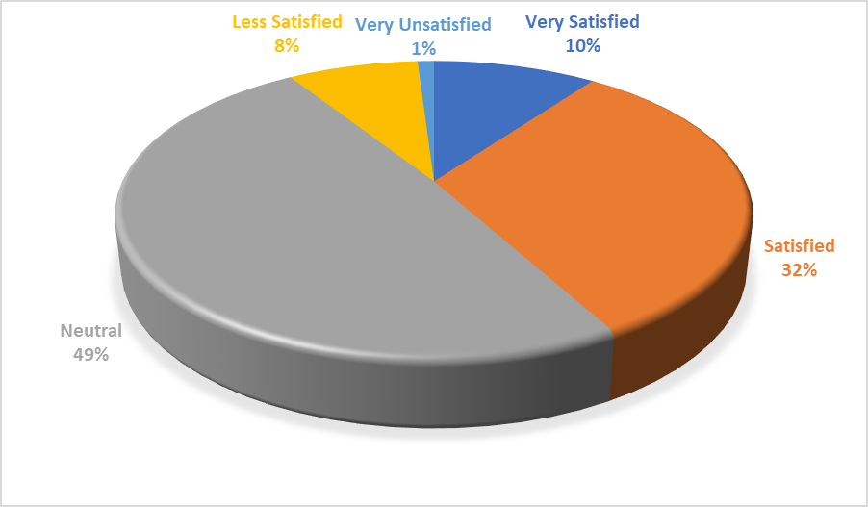

Figure 4.6

This figure indicates how satisfied respondents were with the school's transaction system. Of the 100 respondents, 44 were satisfied with the system, while the remaining 10 were very satisfied, 37 were neutral, 7 were less satisfied, and 2 were very unsatisfied.

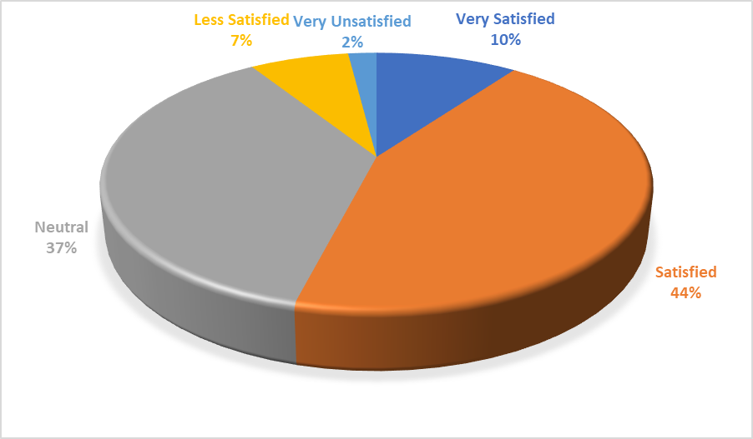

Figure 4.7

This figure indicates how school authorities respond to the implementation of physical social distancing, with 17 in Very Satisfied, 33 in Satisfied, 42 in Neutral, 5 in Less Satisfied, and 3 in Very Satisfied as the results.

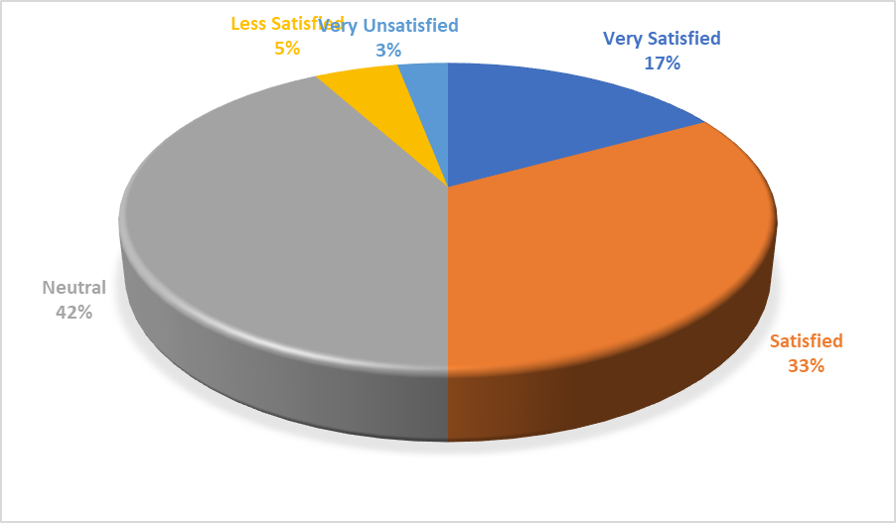

Figure 4.8

This figure also shows how respondents rated PHINMA-University of Pangasinan in terms of service. As shown in the graph, 47 out of 100 respondents are satisfied with the university's service, while the remaining respondents answered 17 in Very Satisfied, 31 in Neutral, 3 in Less Satisfied, and 2 in Very Unsatisfied.

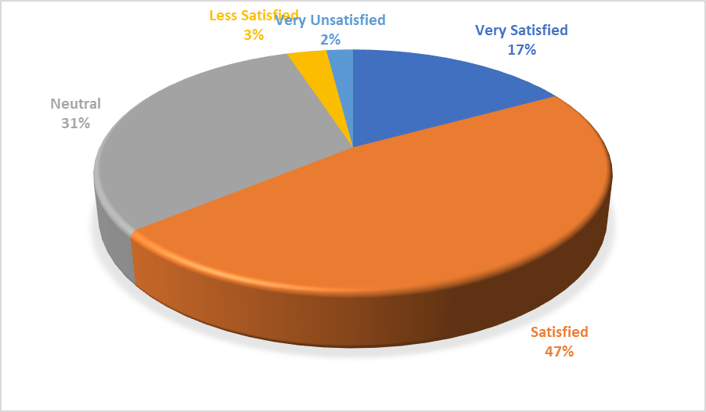

Figure 4.9

This figure describes how the school keeps track of each student's health and updates it on a regular basis, and these are the responses: 12 in Very Satisfied, 39 in Satisfied, 41 in Neutral, 5 in Less Satisfied, and 3 in Very Unsatisfied.

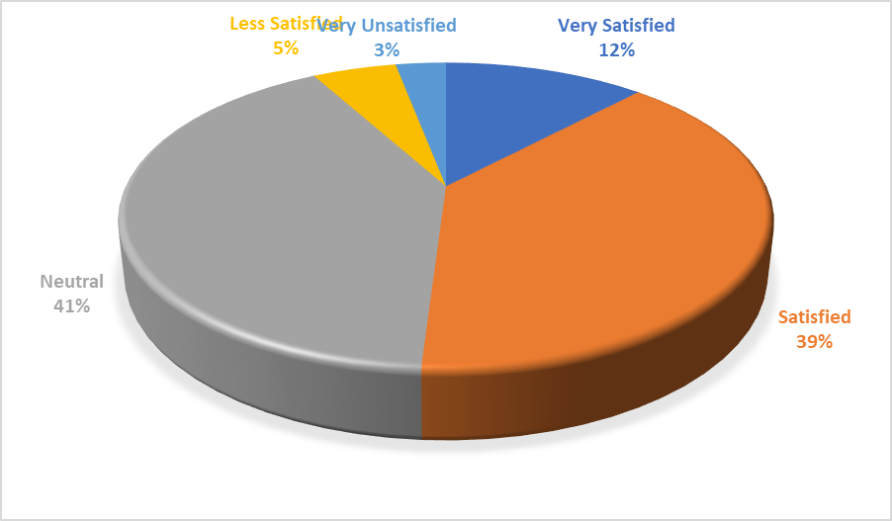

**Figure 4.10**

**Answers to the Statement of the Problems**

1. What are the issues in the existing Scheduling System of PHINMA University of Pangasinan?

The current issues in the existing scheduling/transaction system of PHINMA University of Pangasinan are the following: Long queue lines inside the school gym and the sudden cut off for the tellers’ lunch time break which causes the inconvenience for students to stay in school longer during the tellers’ lunch break.

2. What are the features of the proposed Online Scheduling System for PHINMA University of Pangasinan?

The features are: Google Sign in(PHINMA gmail account), Schedule a transaction, real-time updates if the slot are full per day, real-time monitoring for the current serving queue number. Each teller also has their own unique interface for validation. After the user has decided and entered his or her selected department, transaction, and date, the user will click proceed to display the overview screen. The transactions are only tuition fee and enrollment.

3. What is the level of acceptability of the proposed Online Scheduling System for PHINMA University of Pangasinan?

Based on the online survey that we conducted, the proposed Online Scheduling Management System for PHINMA University of Pangasinan has a high level of acceptability. Many of our respondents in the online survey preferred to use the PHINMA-University of Pangasinan mobile application, which our team is implementing to help us speed up and manage our transactions on campus.

We conducted a SUS Survey to determine the level of acceptability of the proposed Online Scheduling Mobile Application. As a result, when questioned about their willingness to use the system on a regular basis, they strongly agreed, and they strongly agreed that the system was simple and easy to use. According to the results of the SUS Survey, the system's various functions were properly integrated in the features of the proposed Online Scheduling Mobile Application.

**System Design**

**Conceptual Design**

This figure shows the user/student and the admin. where the conceptual design as you can see designs how the app works. from sign in from student and login for the admins. helps and guides you to understand how the flow of this program works and how to operate it.

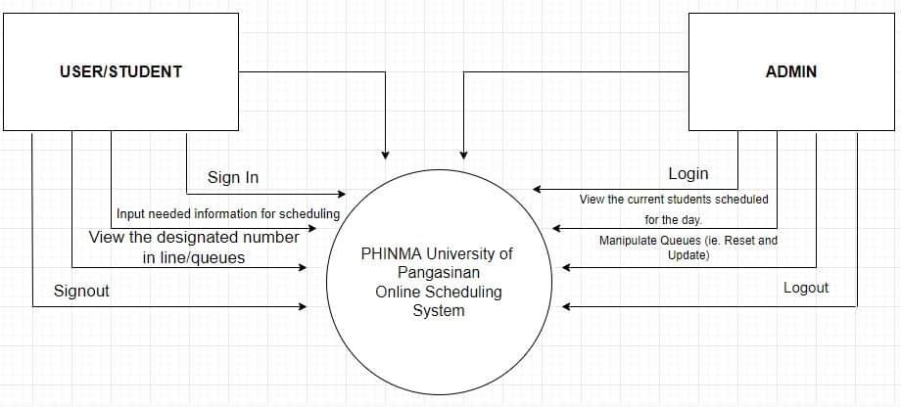

**Figure 5: Conceptual Design**

**Logical Design**

The logical design is like the conceptual design but it is abstract. You do not deal with the physical implementation details yet; you deal only with defining the types of information that you need. The process of logical design involves arranging data into a series of logical relationships called entities and attributes. where as you can see how the data flows on both entity and attribute.

**Figure 6: Logical Design**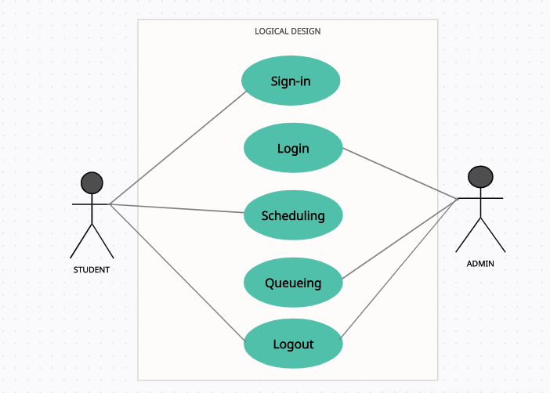

**Physical Design**

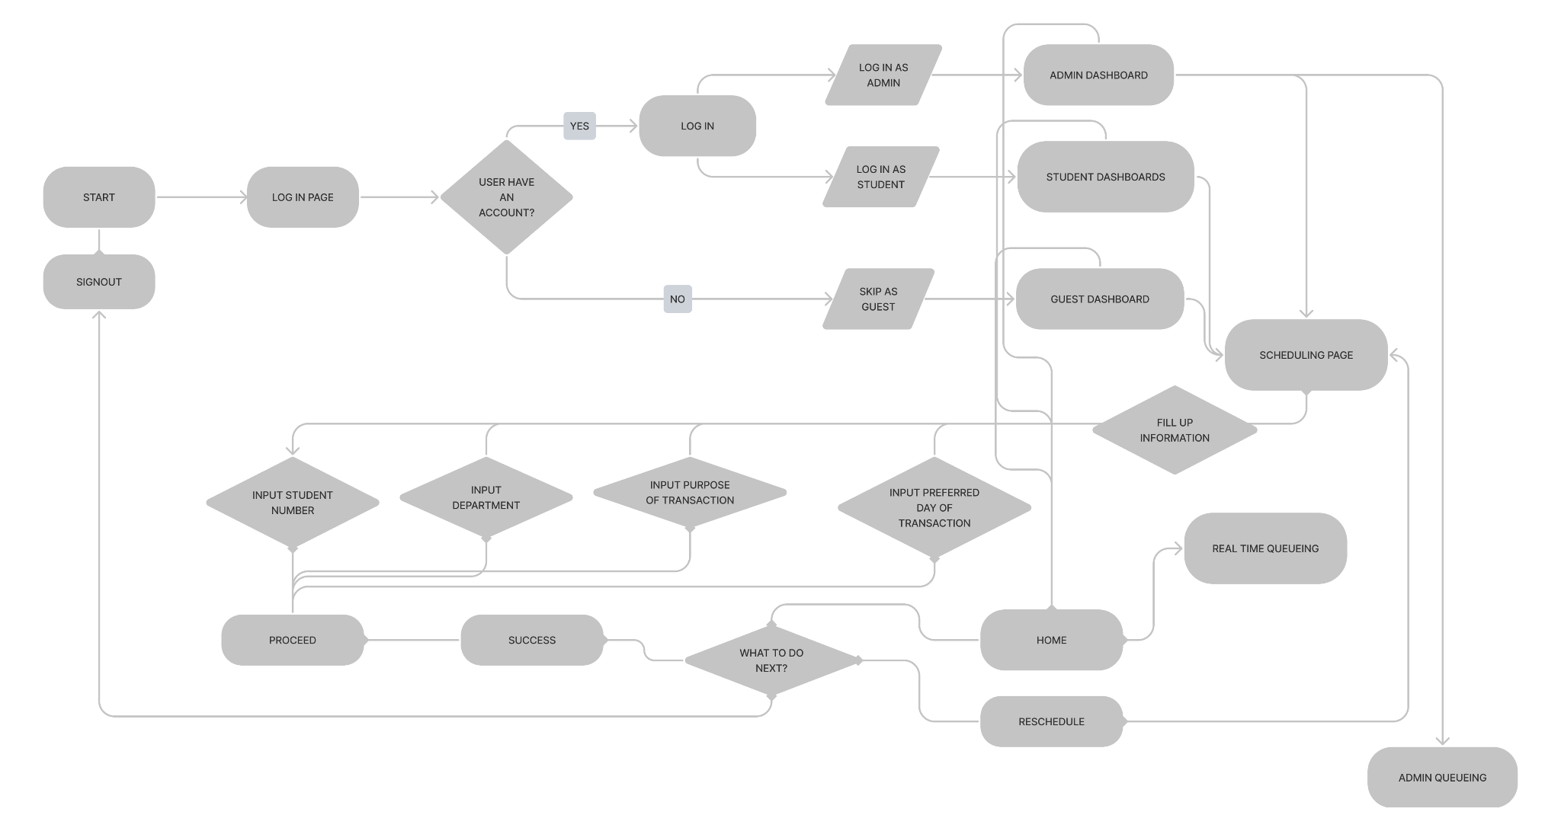

**Figure 7:Physical Design**

Physical design is a kind of system design. It is a graphical illusion of the system representing all the internal and external functions of the ins and outs of the application made.

It is the overview of where the Online Scheduling Management app is based and where it is designed and functioned after.

Chapter 4

**CONCLUSIONS AND RECOMMENDATIONS**

This chapter presents the conclusions and recommendations of the study.

**Conclusions**

Due to the Pandemic that occurred in the early part of 2020 the University operations have been on halt. Students were not able to attend classes and shifted to an adaptive way of learning through online mediums. The pandemic caused havoc in multiple University operations and one of those is the student transactions.

The study that the students aimed to do is to develop an Online Scheduling System made for PHINMA University of Pangasinan to provide a more precise method of scheduling any transactions that occur on the campus.

The developers created this online scheduling system to reduce the volume of people inside the campus when doing their scheduled transactions. When developing the said app, the developers made sure that the app’s usability will be precise for the student/guest that will be using the app and also the admin/staff that will monitor all the preceding transactions scheduled in the app.

The UI developed for the mobile-application is simple to understand yet sophisticated. The app’s features are all working. The scheduling, queueing, queue reset, admin functions, and the real time queueing monitor are all fully functional.

With the surveys conducted the app made a good impression with the 100 respondents which are part of the CITE Department. 47% are satisfied and believe that the app developed is worth having and will help speed up and manage the campus transactions well.

With the New Normal kicking in and less and less restrictions being implemented, we strongly believe that the Online Scheduling System for PHINA University of Pangasinan will be a great help to the University’s problem of managing transactions efficiently.

**Recommendations**

Given that the pandemic affected the lives of every student, parents and even faculty members, we made an application that will make the students, parents and tellers life easier by using our application. The current problems we’ve been facing is how efficient the queueing method in schools makes our lives better.

The new and improved method that we made makes your scheduling way more convenient. It should be quick and easier to understand with the guides that it gives and most of all it is highly efficient. We also recommend our future researchers to study more about how technology becomes so efficient in these kinds of small problems that normal people don’t notice at all, but when we incorporate these systems, it lets them realize that certain problems can be resolved using technology.

**REFERENCES**

A. Published Materials

Design and Appropriation of Computer-supported Self-scheduling Practices in Healthcare Shift Work Alarith Uhde, Matthias Laschke, Marc Hassenzahl (22 April 2021)

Scheduling Content in Pervasive Display Systems Sarah Clinch, Mateusz Mikusz, Ivan Elhart, Nigel Davies, Marc Langheinrich (11 December 2019)

A Distributed Real-time Scheduling System for Industrial Wireless Networks Venkata P. Modekurthy, Abusayeed Saifullah, & Sanjay Madria (29 July 2021)

Deadline-Aware Fair Scheduling for Multi-Tenant Crowd-Powered Systems Djellel Difallah, Alessandro Checco, Gianluca Demartini, Philippe Cudré-Mauroux (21 February 2019)

Application of genetic algorithm for class scheduling (Case study: Faculty of science and technology UIN Jakarta)Sunan Parera, Hushni Teja Sukmana, Luh Kesuma Wardhani (April 2016),

Scheduling and lot sizing with sequence-dependent setup: A literature review by Xiaoyan Zhu &Wilbert E. Wilhelm

OUTPATIENT SCHEDULING IN HEALTH CARE: A REVIEW OF LITERATURE by Tugba Cayirli; Emre VeralProduction and Operations Management; Winter 2003; 12, 4; ABI/INFORM Global

Class Scheduling System for Selected State University by Digna S. Evale Published 2015

B. Websites

<https://aginginplace.org/technology-in-our-life-today-and-how-it-has-changed/>

<https://financesonline.com/appointment-scheduling-statistics/>

<https://up.phinma.edu.ph/our-story/>

**APPENDICES**

Appendix A

**Letter for Panelist**

Dear Mrs. [Neriza Villacorta Bustillo](mailto:nvbustillo.up@phinmaed.com)

We are honored to have you as one of our panelist for our final defense in Capstone Project 2 as detailed below:

Defense Date and Time : March 29, 2022 @3:00 PM-4:00 PM

Project Title : PHINMA University of Pangasinan Online Scheduling Management System

Team Name : Lock Infinity

Leader’s Name : De Guzman, Roger Arthur William A.

Members’ Names :  Erica Mae P. Devera, Glaiza Joyce M. Villanueva, Benjie B. Maramba, Oscar Solomon S. Enriquez, and Ralph Wendell M. Elasin

Our project is a mobile application that aims to make queuing in our school gym more efficient by using a queueing and scheduling system. The features are: a real-time queuing system, a real-time transaction schedule (by day), and a unique real-time queue number per transaction.

We would greatly appreciate your confirmation of your acceptance of our invitation at the soonest possible time.

Very truly yours,

De Guzman, Roger Arthur William A.

09214500862

Appendix B

**Informed Consent and Survey Questionnaire**

College of Information Technology Education   
PHINMA-UPANG  
Dagupan City, Philippines 2400

Informed Consent:

Thank you for participating in this survey. Your feedback is important. Please answer the following questions as honestly as possible. These questions concern the PHINMA University of Pangasinan’s process of transactions that usually happen in the school gym.

We are currently working on a fully functional mobile application that PHINMA University of Pangasinan students can use at any time they log in. Students can inquire about availability and reserve a time slot to ensure and authenticate their transaction on the particular date.  
  
**Our school’s big problem:** Having a long line in our school gym, resulting in a large crowd, which violates COVID standard in some way.

**Project Application:** PHINMA University of Pangasinan Online Scheduling System  
  
To do so, we’d like to hear from you first so that we can support our research.  
  
All information collected will be used only for our research and will be kept confidential. There will be no connection to you specifically in the results or in future publication of the results. Once the study is completed, we would be happy to share the results with you if you desire. In the meantime, if you have any questions and/or concern about your treatment as a participant in this study, please ask or contact: [roal.deguzman.up@phinmaed.com](mailto:roal.deguzman.up@phinmaed.com)

Instructions: Please choose an honest answer in each question and please provide a [√] check inside the boxes for your response.   
Part I: knowing your Details

1. Full Name (Ex. Lastname, Firstname)  
________________________

2. Year Level  
[ ] First Year  
[ ] Second Year

[ ] Third Year

[ ] Fourth Year  
  
About the Project  
Part II: About the current system of transactions in the school (Lining up in gym for inquiries)  
  
1. How is the current process of transaction efficient? (Lining up in the gym to pay tuition fee and enrolment)  
[ ] Always

[ ] Often  
[ ] Sometimes  
[ ] Rarely  
[ ] Never  
  
2. How do you encounter any problems in regard to processing your transaction?  
[ ] Always

[ ] Often

[ ] Sometimes

[ ] Rarely

[ ] Never

3. How do you find our current process of transaction helpful in the time of COVID?  
[ ] Always

[ ] Often

[ ] Sometimes

[ ] Rarely

[ ] Never

4. How do you want a mobile application that can efficiently process your transactions based on the day slot you’ve chosen? (Real time queueing system)  
[ ] Very Likely  
[ ] Likely

[ ] Neutral

[ ] Not Likely

[ ] Very Unlikely  
  
5. How do you want to make your transactions more convenient without having to wait in a long line at school?

[ ] Very Likely

[ ] Likely

[ ] Neutral

[ ] Not Likely

[ ] Very Unlikely   
  
Given the current transaction system of PHINMA University of Pangasinan, rate each question with an honest answer.

|  | Very Satisfied | Satisfied | Neutral | Less Satisfied | Very Unlikely |
| --- | --- | --- | --- | --- | --- |
| How quickly paying tuition or other transactions at the University of Pangasinan are processed. |  |  |  |  |  |
| How satisfied are you with the school's transaction system? |  |  |  |  |  |
| How well do the school authorities respond to implement physical social distancing? |  |  |  |  |  |
| In terms of service, how would you rank PHINMA-University of Pangasinan? |  |  |  |  |  |
| How does the school keep track of each person's health and update it on a regular basis? |  |  |  |  |  |

Appendix C

**SUS Survey**

**Project Mobile Application: PHINMA University of Pangasinan Online Scheduling System**

This online survey is about the System Usability Scale (SUS), which allows us to collect various responses from users regarding their experiences with our Online Scheduling Application. It’s entitled the PHINMA University of Pangasinan Online Scheduling System, and it’s used to test how a user’s transaction is scheduled.

Thank you for your cooperation!

Here is the APK Link for our Application: (Note: It is not yet the official, we will still have changes until March 21)

<https://tinyurl.com/3vdn4u2n>

Note: Make sure to turn off dark mode before using this application.

Please rate your level of agreement with each of the following statements:

|  | Strongly disagree | Disagree | Neutral | Agree | Strongly Agree |
| --- | --- | --- | --- | --- | --- |
| 1. How would you agree or disagree about the likeness you would utilize this system on a regular basis? |  |  |  |  |  |
| 2. How do you agree or disagree about the system being unnecessarily complicated? |  |  |  |  |  |
| 3. How much do you agree or disagree with the statement that the system was simple to use? |  |  |  |  |  |
| 4. How do you agree or disagree that using this system requires the assistance of a technical expert? |  |  |  |  |  |
| 5. How strongly do you agree or disagree that any of the system's various functions were properly integrated? |  |  |  |  |  |
| 6. How do you agree or disagree about the inconsistency of the system? |  |  |  |  |  |
| 7. How do you agree or disagree about the ability of most people in learning this system quickly? |  |  |  |  |  |
| 8. How do you agree or disagree about the system's cumbersomeness? |  |  |  |  |  |
| 9. How do you agree or disagree about the ease upon using the system? |  |  |  |  |  |
| 10. How do you agree or disagree about the difficulty of learning to start and use the system? |  |  |  |  |  |

Appendix D

**Prototype**

In this part of the study, the researchers included the Prototype of our application.  
  
  
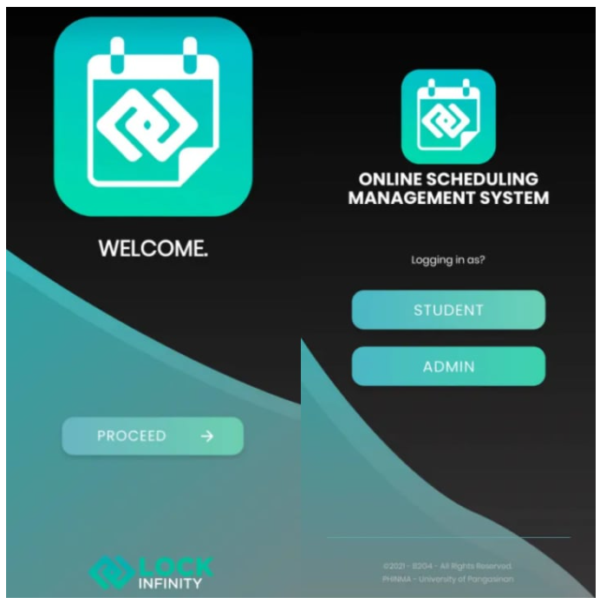  
  
  
  
  
  
  
  
  
  
  
  
  
  
  
  
  
  
  
  
  
  
  
  
  
  
  
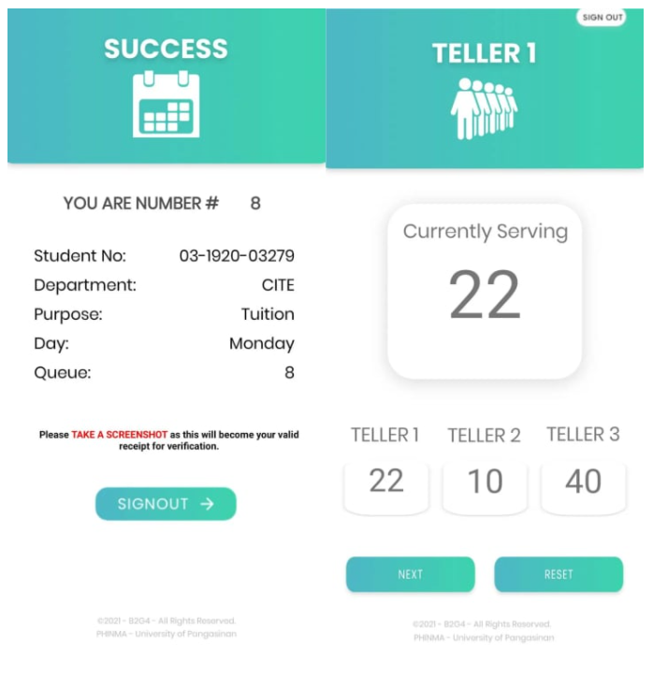  
  
  
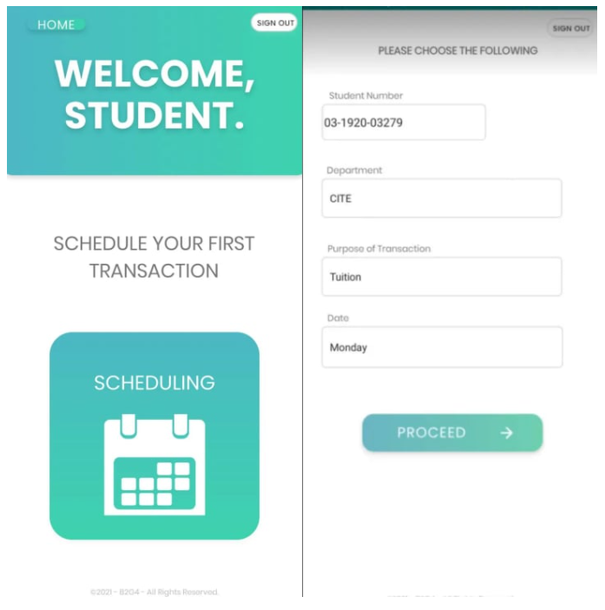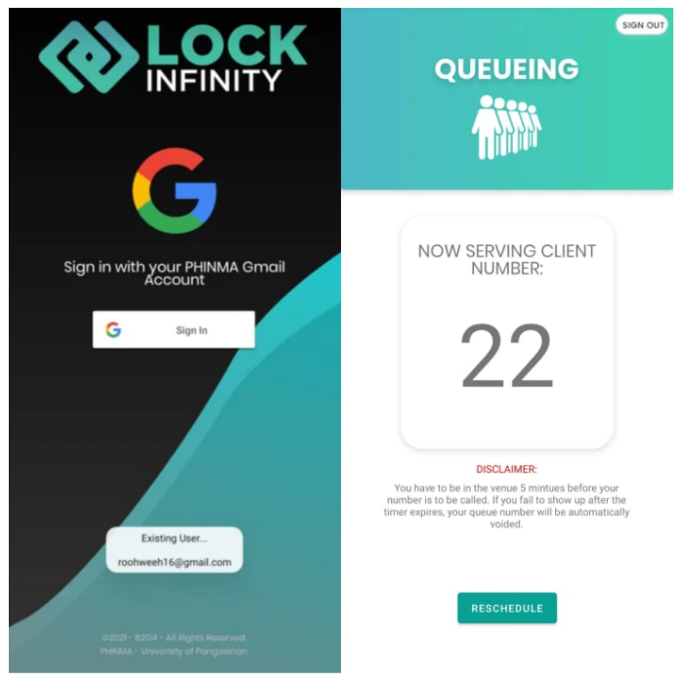

**CURRICULUM VITAE**



**DE GUZMAN, ROGER ARTHUR WILLIAM ALEJO**

#6 Zamora St. Dagupan City Pangasinan

09214500862

[roal.deguzman.up@phinmaed.com](mailto:roal.deguzman.up@phinmaed.com)

**___________________________________________________________**

**PERSONAL INFORMATION**

Birthdate: July 8,2000

Age: 21

Civil Status: Single

Gender: Male

Religious Affiliation: Christian

**___________________________________________________________**

**EDUCATIONAL ATTAINMENT**

Tertiary: Bachelor of Science in Information Technology,

Major in Programming

PHINMA-University of Pangasinan

2019-Present

Secondary: St. John’s Cathedral School

2013-2016

Elementary: West Central Elementary School 1

2006-2013

**___________________________________________________________**

**IT SKILLS AND CERTIFICATIONS**

Special Skills

* Computer Languages
* Adaptability
* Ability to Work Under Pressure
* Time Management

Computer Skills

* + Platforms | Windows 7/8/10
  + Software Microsoft Office (Word, Excel, Powerpoint), SQL, Firebase, Android Studio
  + *Languages* | Java, Python

**___________________________________________________________**

**REFERENCES**

**Rhoda Mailee Christine A. De Guzman**

Business Agent / Car Dealer

Dagupan City, Pangasinan

**CURRICULUM VITAE**



**ERICA MAE P. DE VERA**

#1079 Bayanihan Village, Caranglaan

Dagupan City, Pangasinan

09089596766

[erpa.devera.up@phinmaed.com](mailto:erpa.devera.up@phinmaed.com)

**___________________________________________________________**

**PERSONAL INFORMATION**

Birthdate: August 2, 2000

Age: 21

Civil Status: Single

Gender: Female

Religious Affiliation: Roman Catholic

**___________________________________________________________**

**EDUCATIONAL ATTAINMENT**

Tertiary: Bachelor of Science in Information Technology,

Major in Programming

PHINMA-University of Pangasinan

2019-Present

Secondary: St. John’s Cathedral School

2013-2019

Elementary: Caranglaan Elementary School

2006-2013

**___________________________________________________________**

**IT SKILLS AND CERTIFICATIONS**

* Communication Skills
* Time and Project Management
* Creativity
* Capable for problem solving

**___________________________________________________________**

**REFERENCES**

**Fortunato G. Sanchez**

Brgy. Captain

Caranglaan, Dagupan City Pangasinan

**Aristotle B. Liwanag**

DEAN, College of Information Technology and Education

PHINMA-University of Pangasinan

**CURRICULUM VITAE**



**ELASIN, RALPH WENDELL M.**

Bacayao Norte, Dagupan City

09193777721

[rama.elasin.up@phinmaed.com](mailto:rama.elasin.up@phinmaed.com)

**___________________________________________________________**

**PERSONAL INFORMATION**

Birthdate: December 30, 2000

Age: 21

Civil Status: Single

Gender: Male

Religious Affiliation: Roman Catholic

**___________________________________________________________**

**EDUCATIONAL ATTAINMENT**

Tertiary: Bachelor of Science in Information Technology,

Major in Programming

PHINMA-University of Pangasinan

2019-Present

Secondary: St. John’s Cathedral School

2013-2019

Elementary: Senior Tessor Academy

2006-2013

**___________________________________________________________**

**IT SKILLS AND CERTIFICATIONS**

* Active Listening
* Good in Communication skills
* Computer skills
* Problem-solving
* Time management
* Transferable skills

**___________________________________________________________**

**REFERENCES**

**Ralph Raymund Alarte**

Doctor

Malued, Dagupan City, Pangasinan

**Michelle M. Elasin**

Dentist

Bacayao Norte, Dagupan City, Pangasinan

**CURRICULUM VITAE**



**OSCAR SOLOMON S. ENRIQUEZ**

3 Ayungin Street, Blue Beach Subdivision

Bonuan Gueset, Dagupan City

0908 875 8469

[ossa.enriquez.up@phinmaed.com](mailto:ossa.enriquez.up@phinmaed.com)

**___________________________________________________________**

**PERSONAL INFORMATION**

Birthdate: December 28, 1999

Age: 22

Civil Status: Single

Gender: Female

Religious Affiliation: Born-Again Christian

**___________________________________________________________**

**EDUCATIONAL ATTAINMENT**

Tertiary: Bachelor of Science in Information Technology

Major in Programming

PHINMA-University of Pangasinan

2019-Present

Secondary: La Marea Academy (STEM Strand)

2016-2017

Elementary: Davao Christian High School

2012

**___________________________________________________________**

**IT SKILLS AND CERTIFICATIONS**

* MS OFFICE
* ADOBE PHOTOSHOP (UDEMY CERTIFICATION)
* ADOBE PREMIERE (UDEMY CERTIFICATION)
* ADOBE AFTER EFFECTS (UDEMY CERTIFICATION)
* ADOBE XD (UDEMY CERTIFICATION)
* UI/UX TRAINING (UDEMY CERTIFICATION)
* VIDEO EDITING (ACE CERTIFICATION)
* LIVE STREAMING AND SOUND ENGINEERING (MARK YULO OFFICIAL)
* ABLETON MASTERCLASS (ABLETON NEWSLETTER CERTIFICATION)
* PHOTOSHOP CLASS FOR WEB DESIGN AND WEB GRAPHICS (AGITRAINING CERTIFICATION)
* OBS LIVE STREAMING TRAINING WITH SOUND MIXING (MARK YULO CERTIFICATION)
* CSS and HTML

**___________________________________________________________**

**REFERENCES**

**MARISSA HARRIS** – GRAPHICS TEAM LEAD – BMW, DALLAS, TEXAS

**MARK YULO** – SOUND ENGINEER AND MIXING MASTER – MARIKINA, METRO MANILA, PHILIPPINES

**HANNAH PANGILINAN** – YOUTUBE VLOGGER – TAGUIG, PHILIPPINES

**CURRICULUM VITAE**



**Maramba, Benjie Bitolinamesa**

1585 Bagong Barrio Street, Bonuan Binloc,

Dagupan City, Pangasinan

09123716971

[bebi.maramba.up@phinmaed.com](mailto:bebi.maramba.up@phinmaed.com)

**___________________________________________________________**

**PERSONAL INFORMATION**

Birthdate: March 24, 2001

Age: 20

Civil Status: Single

Gender: Male

Religious Affiliation: Baptist

**___________________________________________________________**

**EDUCATIONAL ATTAINMENT**

Tertiary: Bachelor of Science in Information Technology

Major in Programming

PHINMA-University of Pangasinan

2019-Present

Secondary: Federico N. Ceralde Integrated School

2012-2019

Elementary: Federico N. Ceralde Integrated School

2006-2013

**___________________________________________________________**

**IT SKILLS AND CERTIFICATIONS**

CISCO Certified Entry Networking Technician

Agile Product Lifecycle Management Certification

Knowledge on Java, Python, Fortran, Cobol, and C#.

**___________________________________________________________**

**REFERENCES**

Dr. Fe Calicdan

09469447043

Kgwd. Wilmer Castanares

09123716971

**CURRICULUM VITAE**



**VILLANUEVA, GLAIZA JOYCE MAMARIL**

Bonuan Binloc, Dagupan City

09662979859

[glma.villanueva.up@phinmaed.com](mailto:glma.villanueva.up@phinmaed.com)

**___________________________________________________________**

**PERSONAL INFORMATION**

Birthdate: July 16, 2001

Age: 20

Civil Status: Single

Gender: Female

Religious Affiliation: Roman Catholic

**___________________________________________________________**

**EDUCATIONAL ATTAINMENT**

Tertiary: Bachelor of Science in Information Technology

Major in Programming

PHINMA-University of Pangasinan

2019-Present

Secondary: Federico N. Ceralde Integrated School

2012-2019

Elementary: Federico N. Ceralde Integrated School

2006-2012 **___________________________________________________________**

**IT SKILLS AND CERTIFICATIONS**

* CSS and HTML
* Documentation

**___________________________________________________________**

**REFERENCES**

Jushua C. Gonzales (Kagawad Captain)